A
Project Report
On
SMART HELMET FOR RIDERS TO AVOID
ACCIDENTS USING IoT
Submitted to
CHADALAWADA RAMANAMMA ENGINEERING COLLEGE
In partial fulfillment of the requirements for the award of the Degree of

BACHELOR OF TECHNOLOGY
in

ELECTRONICS & COMMUNICATION ENGINEERING
By
C. THANUJA 21P11A0423
A. JAYA SREE 21P11A0404
D. BHARATH KUMAR 21P11A0425
G. MANOJ 21P11A0432
Under the Esteemed Guidance of
Mr. S. ALI ASGAR
Assistant Professor

DEPARTMENT OF ELECTRONICS & COMMUNICATION ENGINEERING
CHADALAWADA RAMANAMMA ENGINEERING COLLEGE (AUTONOMOUS)
(Accredited by NAAC , Approved by AICTE, New Delhi, Affiliated to JNTU Anantapur)
Renigunta road, Tirupati-517506, Andhra Pradesh, India
2021-2025
CHADALAWADA RAMANAMMA ENGINEERING COLLEGE
(AUTONOMOUS)
DEPARTMENT OF ELECTRONICS & COMMUNICATION ENGINEERING



Certificate
This is to certify that the project work entitled “SMART HELMET FOR RIDERS TO AVOID ACCIDENTS USING IoT”, is a bonafide work done by C. THANUJA (21P11A0423), A. JAYA SREE (21P11A0404), D. BHARATH KUMAR (21P11A0425), G. MANOJ (21P11A0432) in the Department of “ELECTRONICS AND COMMUNICATION ENGINEERING”, and submitted to Chadalawada Ramanamma Engineering College (Autonomous), Tirupati in partial fulfillment of the requirements for the award of the Bachelor of Technology and the Project work carried out by them under my guidance during the academic year 2024-25.

GUIDE HEAD

Mr. S. ALI ASGAR Dr. M. VIJAYA LAXMI Assistant Professor Professor
Department of ECE Department of ECE

Submitted for viva-voce examination held on

INTERNAL EXAMINER EXTERNAL EXAMINER

DECLARATION

It hereby declare that the project work on “SMART HELMET FOR RIDERS TO AVOID ACCIDENTS USING IoT”, done by us under the guidance of Mr. S. ALI ASGAR in CHADALAWADA RAMANAMMA ENGINEERING COLLEGE (Autonomous) is submitted in partial fulfillment of the requirements of the award of Degree of Bachelor of Technology.
It declares that this written submission represents our ideas in our own words and where other’s ideas or words have been included, it has adequately cited and referenced the sources. It also declares that it has adhered to all principles of academic honesty and integrity and have not misrepresented or fabricated or falsified any idea/data/fact/source in our project report submission.

Signature of the Students
C. THANUJA 21P11A0423
A. JAYA SREE 21P11A0404
D. BHARATH KUMAR 21P11A0425
G. MANOJ 21P11A0432

ACKNOWLEDGEMENT
A grateful thanks to Dr. CHADALAWADA KRISHNA MURTHY, Chairman, C.V.S. Krishna Murthy Teja Charities for providing education in this esteemed Institution.
It express our gratitude to our principal Dr. P. SANJEEVA RAYUDU, Principal, Chadalawada Ramanamma Engineering College (Autonomous), Tirupati, for providing all the facilities and supporting us to complete this project work.
Our sincere thanks to Dr. M. VIJAYA LAXMI, Professor and Head, of the Department of Electronics & Communication Engineering, Chadalawada Ramanamma Engineering College (Autonomous), Tirupati, for providing infrastructural facilities to complete our project work.
It is greatly indebted to our guide, Mr. S. ALI ASGAR, Assistant Professor of Electronics & Communication Engineering, Chadalawada Ramanamma Engineering College (Autonomous), Tirupati, who encourages us in all spheres of activities, constant encouragement and keen interest enriched to complete this work.
It extend our thanks to all the Teaching staff of the Department of E.C.E. for their support, encouragement and inspired us. I also thank the Non-Teaching staff of the Department of E.C.E. for being helpful in many ways in successful completion of our work.
The chain of our gratitude would be definitely incomplete, if It forget to thank all my friends of Chadalawada Ramanamma Engineering College (Autonomous), Tirupati for their constant support and encouragement. Finally, I thank all those who helped us directly or indirectly in successful completion of our project work.
C. THANUJA 21P11A0405
A. JAYA SREE 21P11A0451
D. BHARATH KUMAR 21P11A0424
G. MANOJ 21P11A0438

ABSTRACT
The Smart helmet for riders to avoid accidents using IOT leverages advanced technologies to enhance rider safety and prevent accidents. Central to this system is an Arduino microcontroller that integrates various sensors and components to moniter and respond to different safety parameters. An IR sensor detects whether the helmet is worn, ensuring the system is only active when the helmet is in use. An alcohol sensor checks the rider’s breath for alcohol content, preventing the vehicle from starting if the alcohol level is above the legal limit. A MEMS sensor detects accidents by monitoring sudden impacts or falls. An eye blink sensor tracks the rider’s alertness, identifying signs of drowsiness. An LCD displays real-time status and alerts, while a GSM module sends messages with location data, obtained via GPS, to emergency contacts in case of an accident. A DC motor, controlled by a relay, ensures the vehicle starts only under safe conditions, remaining off during any detected abnormalities. Additionally, a NodeMCU module is used to send real-time data to ThingSpeak, enabling continuous monitoring and data analysis. This comprehensive system aims to reduce the risk of accidents and provide immediate assistance, thereby improving rider safety through IOT and embedded systems.

TABLE OF CONTENT
TITLE |  | PAGE.NO
CHAPTER 1 : INTRODUCTION |  | 01
CHAPTER 2 : LITERATURE SURVEY |  | 03
CHAPTER 3 : EXISTING METHOD |  | 21
CHAPTER 4 : PROPOSED METHOD |  | 22
4.1 BLOCK DIAGRAM |  | 22
4.2 EMBEDDED SYSTEM |  | 23
4.3 HARDWARE COMPONENTS |  | 26
4.4 SOFTWARE COMPONENTS |  | 50
CHAPTER 5 : RESULTS AND DISCUSSIONS |  | 59
CHAPTER 6 : ADVANTAGES AND APPLICATIONS |  | 62
CHAPTER 7: CONCLUSION AND FUTURE SCOPE |  | 63
7.1 CONCLUSION |  | 63
7.2 FUTURE SCOPE |  | 63
REFERENCES |  | 64

LIST OF FIGURES
FIGURE NO | TITLE | PAGE NO
4.1 | Block Diagram of The Project | 22
4.2 | Block Diagram of Embedded System | 24
4.3 | Harvard Architecture | 25
4.4 | Von-Neumonn Architecture
4.5 | Arduino Types | 27
4.6 | Arduino Board | 27
4.7 | Arduino UNO | 28
4.8 | GSM Modem | 31
4.9 | Power supply | 32
4.10 | How Infrared Sensor works | 33
4.11 | MEMS Sensor | 35
4.12 | GPS Receiver | 36
4.13 | GPS Serial Interface | 36
4.14 | DC Motor | 37
4.15 | Buzzer | 38
4.16 | LCD Display | 42
5.1 | Hardware Setup | 59
5.2 | Information displayed in LCD | 60
5.3 | Location Tracking | 61
LIST OF TABLES
Table No | Title | Page No
4.1 | Address locations for a 1x16 line LCD | 45

CHAPTER 1
INTRODUCTION
Different technological terms such as Telecommunications, Internet of Things (IoT), and robotics have been considered a vital part of our daily activities. Internet of things are currently being used in many fields such as wearable’s, home automations, smart appliances, smart agriculture etc. where there is a mutual communication between devices and people over a network. The work of the IOT devices is to sense the data and send the data to server by this huge amount of data can be generated. By the generated data we can draw the conclusion by processing and analyzing the data obtained. This gives the advantage in real time data reporting from environment. Now a days motorbike accidents are increasing day by day and we can notice numerous losses in lives. We can avoid this by using smart helmet. From the survey we can know that in India 4 people die every hour because they do not wear helmet. In 2017, more than 48,746 two-wheeler users died in road accidents, Incidental 78.3% of them did not wear a helmet. To go through or to solve this, there are two important conditions that should be checked before the bike starts by the smart helmet. First most condition is that we should check whether the rider is using the helmet and not just keeping it. Second to check whether the user has consumed alcoholic substance or not by his breath, this can be verified by using sensors. Third if a person meets with an accident, the sensor check the condition of person and bike and send information of location to nearby hospital. If the person has no major injurious then the button is pressed which is present in the bike this indicate that the person condition is good. The Smart helmet for riders to avoid accidents using IOT leverages advanced technologies to enhance rider safety and prevent accidents. Central to this system is an Arduino microcontroller that integrates various sensors and components to moniter and respond to different safety parameters. An IR sensor detects whether the helmet is worn, ensuring the system is only active when the helmet is in use. An alcohol sensor checks the rider’s breath for alcohol content, preventing the vehicle from starting if the alcohol level is above the legal limit. A MEMS sensor detects accidents by monitoring sudden impacts or falls. An eye blink sensor tracks the rider’s alertness, identifying signs of drowsiness. An LCD displays real-time status and alerts, while a GSM module sends messages with location data, obtained via GPS, to emergency contacts in case of an accident. A DC motor, controlled by a relay, ensures the vehicle starts only under safe conditions, remaining off during any detected abnormalities. Additionally, a NodeMCU module is used to send real-time data to ThingSpeak, enabling continuous monitoring and data analysis. This comprehensive system aims to reduce the risk of accidents and provide immediate assistance, thereby improving rider safety through IOT and embedded systems

CHAPTER 2
LITERATURE SURVEY

PAPER-1

Kamdi.R, Vaidya.R, Borakhade.D, Thakre, P.Nilawar, V. Panchabhai “An IoT Based intelligent and Smart Helmet for Bike Riders Using Arduino”. International Journal of Intelligent Systems and Applications in Engineering, 7 January, 2024.
Description
The system likely uses an Arduino microcontroller, sensors, and IoT connectivity to create a "smart" helmet. It might monitor factors like helmet wearing, impact detection, rider location, and potentially even vital signs. This proposal also helps to understand IoT technology which is being emerged now a days. From the method proposed using Arduino UNO, MEGA and other cost-effective sensors like an IR sensor. The bike engine will start only when the rider will worn the helmet. It detects the head of the bike rider within the range. A Radio Frequency (RF) Module is used for wireless communication between helmet unit as transmitter and bike unit as receiver. Ultrasonic senor used to detect nearby approaching vehicle’s and send voice alerts to rider by speakers, Most important utility of this method is that fall detection using Vibrator Sensor and GSM & GPS module system is included so that emergency medical service can easily track the location of the incident occurs and also sending SMS message alert to the emergency number of the rider stored. Smart helmet system helps to provide accident detection, safety and security to the two-wheeler riders.
Key features
1. Accident Detection: Smart helmets are equipped with sensors to detect accidents and alert emergency services.
2. GPS Tracking: Smart helmets feature GPS tracking to provide real-time location information.
3. Voice Assistant: Smart helmets have a voice assistant for hands-free communication.
4. Bluetooth Connectivity: Smart helmets feature Bluetooth connectivity for hands-free communication.
5. Rechargeable Battery: Smart helmets are powered by a rechargeable battery.
6. Mobile App Control: Smart helmets can be controlled using a mobile app.
7. Sensor Integration: Smart helmets integrate various sensors, including accelerometers, gyroscopes, and GPS.8. Alert System: Smart helmets have an alert system to notify emergency services in case of an accident.
Advantages

Improved rider safety

Real time accident detection and reporting

Theft prevention and data collection for analysis
Disadvantages
- High cost and complexity and False alarms

PAPER-2

Kabilan M, Monish S, Dr S. Siamala Devi “Accident detection system based on IoT-Smart Helmet” IJARIIT, 2021.

Description
This paper presents a system using vibration sensors. When the rider wear the helmet consisting of the vibrator sensor with a frequency if the frequency crosses the threshold then the message is sent to the emergency responses using GPS module. This system helps to detect and report the accident and can save the life. Using the Internet of Things, smart helmets will be able to identify accidents and send alerts to nearby emergency services as well as medical facilities. In this case, an accelerometer module is used to detect accidents by constantly monitoring the deviations from the normal conditions. In the event of a collision, the exact location of the rider can be determined and forwarded to the relevant authorities. The primary function of this system is to transmit accurate information related to the accident in the form of text messages and phone calls to predetermined contacts.
Key Features
1. Accident Detection: Smart helmets can detect accidents using sensors such as accelerometers and gyroscopes.
2. Real-time Alerts: Smart helmets can send real-time alerts to emergency services in the event of an accident.
3. Alcohol Detection: Smart helmets can detect alcohol levels in the rider's breath, preventing drunk driving.
4. Fatigue Detection: Smart helmets can detect fatigue and distraction in riders, enabling them to take corrective action.
5. Real-time Feedback: Smart helmets can provide riders with real-time feedback on their riding habits, helping them to improve their safety.
6. GPS Tracking: Smart helmets can provide GPS tracking, enabling riders to be located in the event of an accident.
Advantages
- Alcohol detection
- Real time alerts
Disadvantages
- Network issues.

PAPER-3

K. Mhatre, R. Nandwadekar, A. Patil, R. Shinde, P. Kamble, Smart Helmet With Intercom Feature, in the Proceedings of the 3rd International Conference on Advances in Science & Technology (ICAST2020), April 8, 2020.

Description
Proposed a system which consists of helmet module and bike module. It consists of IR sensors, MQS alcohol sensor, vibration sensor, GSM module, GPS module, Arduino, Intercom system. The workflow of the system is as follow, when the bike starts if the rider has consumed the alcohol and if it is greater than the threshold then the bike don’t start else the bike will start and if the vibration sensor limit is greater than the threshold message is sent to the registered number about the accident. This system is cost effective and provide better security to the biker. Smart helmets with intercom features enable riders to communicate with each other in real-time, enhancing their safety and riding experience. These helmets are equipped with advanced technologies such as Bluetooth, Wi-Fi, and GPS, enabling riders to stay connected and navigate through routes. The intercom feature allows riders to communicate with each other, share information, and coordinate their actions, reducing the risk of accidents.
Key Features
1. Intercom Feature: Enables riders to communicate with each other in real-time.
2. Bluetooth Connectivity: Enables riders to connect their helmets to their smartphones or other devices.
3. GPS Navigation: Provides riders with turn-by-turn directions and navigation.
4. Voice Assistant: Enables riders to access information and services using voice commands.
5. Noise Cancellation: Reduces ambient noise and enhances audio quality.
6. Hands-Free Operation: Enables riders to operate the helmet's features without using their hands.
Advantages
- This system is cost effective.

Provides better security to the rider.
Disadvantages
- Need of 3.3V voltage supply for RF module.

PAPER-4

N Divyasudha, P. Arulmozhivarman, E. R. Rajkumar, Analysis of Smart helmets and Designing an IoT based smart helmet: A cost effective solution for Riders, in the Proceedings of 1st International Conference on Innovations in Information and Communication Technology (ICIICT2019), Chennai, India(2019).

Description
In this paper we are focusing on a system consists of micro controller, position sensor, Alcohol sensor, piezoelectric sensor, RF Transmitter, IOT Modem, GPS receiver, Power supply & Solar panel to avoid the accidents and check the alcohol consumption. In this system two condition is checked that is whether the rider is wearing the helmet or not and to check whether he had consumed alcohol or not if this is not followed by the rider the bike will not start and it is indicated by beep sound. If any accident Occur it is informed to predefined number and police station using IOT modem. This system is cost efficient compare to other kind of helmets.
Key Features
1. Accident Detection: Detects accidents using sensors such as accelerometers and gyroscopes.
2. Real-time Alerts: Sends alerts to emergency services in the event of an accident.
3. GPS Tracking: Provides location-based services and enables riders to be tracked in real-time.
4. Rider Behavior Monitoring: Monitors rider behavior, including speed, acceleration, and braking.
5. Sensor Integration: Integrates various sensors, including accelerometers, gyroscopes, and GPS.
6. Microcontroller Programming: Programs the microcontroller to process sensor data and send alerts.
7. Communication Protocol Development: Develops a communication protocol to enable the helmet to send alerts and receive updates.
8. Low Power Consumption: Optimizes power consumption to ensure extended battery life.
Advantages

It is cost effective compared to other kind of helmets.

Real-time monitoring.
Disadvantages
- Integrating multiple sensors and modules may increase complexity of the helmet.

PAPER-5

A. Jesudoss, R. Vybhavi, B. Anusha, Design of Smart Helmet For Accident Avoidance, in the Proceedings of the International Conference on Communication and Signal Processing(ICCSP2019), April 4-6, 2019, India, (2019).

Description

Proposed a mechanism, where sensors such as IR sensor, vibration sensor and gas sensor, mems are used. The gas sensor is used to detect the amount of liquor he had consumed by checking the breath of a person wearing the helmet. The bar control of the vehicle is handled by MEMS. Accident is detected by vibration sensor. Load of the vehicle is recognized by load checker. The Sensors are interfaced with the PIC microcontroller. The gas sensor will detect if a user consumed alcohol and display on the LED display. If an accident occurs the vibration sensor, sense the accident and send information through GPS to the hospital. If there is any rash driving is done by the rider the MEME sensor detect the amount of the person from his bank account. To check whether the rider is wearing the helmet or not IR sensor is used. In this system exactness and accuracy are high and ambulance is booked automatically based on ten location.
Key Features
1. Advanced Sensors: Equipped with advanced sensors, including cameras, radar, and lidar, to detect potential accidents.
2. Real-time Alerts: Provides real-time alerts and warnings to riders, helping them to avoid accidents.
3. Collision Detection: Detects potential collisions and provides warnings to riders.
4. Blind Spot Detection: Detects vehicles in the blind spot and provides warnings to riders.
5. Lane Departure Warning: Warns riders if they drift out of their lane.

Advantages

Exactness and accuracy are high.

Quick Accident Detection and alcoholic detection.
Disadvantages

System reliability and effectiveness.

PAPER-6

M. Uniyal, H. Rawat, M. Srivastava and V. K. Srivastava, "IoT based Smart Helmet System with Data Log System," 2018 International Conference on Advances in Computing, Communication Control and Networking (ICACCCN2018), Greater Noida, India, (2018).

Description

This contains a system with two units that is helmet unit and two wheeler unit. RF receiver of the matching frequency gives the helmet position data to the two wheeler section. The microcontroller placed on the TW section will have information of the helmet position which is continuously checked. There are various sensors which collects data to the server when there is internet connection. In this system people can access the speed of the vehicle. The data log system provides riders with valuable insights into their riding habits, including speed, acceleration, braking, and cornering. This data can be used to improve riding skills, reduce the risk of accidents, and enhance overall safety. The system also enables riders to track their journey, including route, distance, and time, providing a valuable record of their riding experience.

Key Features

1. Advanced Sensors: Equipped with advanced sensors, including accelerometers, gyroscopes, and GPS.

2. IoT Connectivity: Enables real-time data transmission to the cloud for analysis and storage.

3. Data Log System: Provides riders with valuable insights into their riding habits, including speed, acceleration, braking, and cornering.

4. Ride Tracking: Enables riders to track their journey, including route, distance, and time.

5. Real-time Alerts: Provides real-time alerts and warnings to riders, helping them to avoid accidents.

Advantages

Tilt angle of the vehicle is also detected using accelerometer module. This helps us to know whether the vehicle is fallen or not.
Disadvantages
- Need of internet connection.

PAPER-7

P. Ahuja and K. Bhavsar, Microcontroller Based Smart Helmet Using GSM & GPRS, in the Proceedings of the 2nd International Conference on Trends in Electronics and Informatics(ICOEI2018),Tirunelveli, India,(2018)

Description
Proposed smart Helmet system using GSM and GSRM module. Consists of IR sensor, tilt sensor, NC sensor, microcontroller interface, GSM, GPRS connected to mobile. The arrival of ambulance of the location may be late this prototype helps to inform the concerned person first about the accident and he may take steps. The smart helmet uses GSM and GPRS connectivity to enable real-time communication between the helmet and emergency services. In the event of an accident, the helmet sends an SOS message to pre-programmed emergency contacts, providing them with the rider's location and other critical information. The helmet also receives real-time updates on weather, traffic, and road conditions, enabling riders to make informed decisions and stay safe on the road.
The smart helmet's advanced safety features, including collision detection, blind spot detection, and lane departure warning, provide riders with real-time alerts and warnings, helping them to avoid accidents. The helmet's microcontroller also analyzes data from various sensors to provide riders with valuable insights into their riding habits, including speed, acceleration, braking, and cornering.
Key Features
1. Microcontroller-Based: Equipped with a microcontroller that processes data from various sensors.
2. GSM and GPRS Connectivity: Enables real-time communication between the helmet and emergency services.
3. SOS Messaging: Sends an SOS message to pre-programmed emergency contacts in the event of an accident.
4. Real-Time Updates: Receives real-time updates on weather, traffic, and road conditions.
5. Collision Detection: Detects potential collisions and provides warnings to riders.
6. Blind Spot Detection: Detects vehicles in the blind spot and provides warnings to riders.
7. Lane Departure Warning: Warns riders if they drift out of their lane.
8. Ride Tracking: Enables riders to track their journey, including route, distance, and time.
Advantages

High accuracy and cost effective.

Gives information about accident within a minute.
Disadvantages
- The tilt sensor may fail to detect.

PAPER-8

Agung Rahmat Budiman, Dodi Wisaksono Sudiharto, Tri Brotoharsono “The Prototype of Smart Helmet with Safety Riding Notification for Motorcycle Rider” 2018 3rd International Conference on Information Technology, Information Systems and Electrical Engineering(ICITISEE),Yogyakarta, Indonesia.
Description

This is system of smart helmet which is integrated with several functionalities. Warning notification is given if a rider is not wearing helmet and if he come with unsafe conditions and if helmet is not correctly locked so that to provide safety to the rider. In this system warning to the rider is generated in the form of notification to notify him in the unsafe condition. In the functionality test it is 100% success rate in 4 smart helmet features and 98.3% success rate in the communication test between the 2 modules.
Key Features
1. Advanced Sensor System: Monitors the rider's behavior, including speed, acceleration, braking, and cornering.
2. GPS Module: Provides location-based services, enabling riders to navigate through unfamiliar routes and receive real-time traffic updates.
3. Bluetooth Connectivity: Enables riders to receive safety notifications and alerts on their smartphones.
4. Collision Detection: Detects potential collisions and sends alerts to the rider's smartphone.
5. Blind Spot Detection: Detects vehicles in the blind spot and provides warnings to riders.
Advantages

Real-time notifications.

Enhanced Rider Safety
Disadvantages
- No alcohol detection.
PAPER-9

Archana.D, Boomija.G, Manisha.J, Kalaiselvi.V.KG “Mission On! Innovations in Bike Systems to Provide a Safe Ride Based on IOT” @IEEE 2017.
Description
This contains a system to reduce accidents, here the system consists of a sensor which sense the human touch when he plugs in the bike key. After he wear helmet the sensor automatically lock the helmet and he can only remove is when bike is stopped. The Smart Helmet's real-time alerts warn riders of potential hazards such as collisions, road debris, or inclement weather, enabling them to take evasive action and avoid accidents. The system's integrated GPS provides turn-by-turn navigation, ensuring riders stay on course and avoid potential hazards. Furthermore, the Smart Helmet's cloud-based platform provides valuable insights into riding habits and safety trends, enabling riders to refine their skills and minimize risk. The benefits of the Smart Helmet are multifaceted.
Advantages

Reduction in accidents and injuries due to the forced helmet usage.

It prevents head injuries in case of accidents.
Disadvantages
- Proper power supply should be provided

PAPER-10

C. J. Behr, A. Kumar and G.P. Hancke “ A Smart Helmet for Air Quality and Hazardous Event Detection for the Mining Industry” @IEEE 2016.
Description
This model proposed a system of smart mining helmet that detects three types of hazards that is harmful gases, remove of helmet and if any collision. Here they uses many sensors such as IR sensors, gas sensors, accelerometer. By enhancing road safety, the system reduces the risk of accidents and fatalities, providing riders with an added layer of protection. The Smart Helmet's GPS and navigation features also improve the riding experience, ensuring riders stay on course and avoid potential hazards. Additionally, the system's real-time alerts enhance situational awareness, enabling riders to respond quickly to changing road conditions. The smart helmet for air quality and hazardous event detection is a cutting-edge safety device designed specifically for the mining industry. This innovative helmet integrates advanced sensors and IoT technology to detect and alert miners to potential hazards, including poor air quality, gas leaks, and explosive events. The helmet's IoT connectivity enables real-time data transmission to a central monitoring system, where it can be analyzed and acted upon by mine safety personnel. The system can also provide miners with real-time alerts and warnings, enabling them to take evasive action and avoid potential hazards.
Key Features
1. Advanced Sensors: Equipped with a range of sensors, including gas sensors, matter sensors, and temperature sensors.
2. Real-Time Data Transmission: Transmits real-time data to a central monitoring system for analysis and action.
3. IoT Connectivity: Enables real-time communication between the helmet and the central monitoring system.
4. Air Quality Monitoring: Continuously monitors air quality and provides real-time data on potential hazards.
5. Gas Leak Detection: Detects gas leaks and provides real-time alerts and warnings.
6. Explosive Event Detection: Detects explosive events and provides
Advantages
- Detects hazards in mining areas and industries.
Disadvantages
- Distance of workers want to be limited from interface

.

CHAPTER 3
EXISTING METHOD
With the rise of electric bikes, safety has become a top priority for riders. E-bikes offer speed and efficiency, but that also means cyclists need more advanced protective gear than a standard helmet. Enter the smart helmet – an innovation designed to provide enhanced safety and convenience.
Traditional helmets provide only passive safety by offering physical protection to riders during accidents. They lack active safety measures such as accident detection, intoxication monitoring, or alert systems for emergencies. This limited functionality can result in delayed medical assistance or increased risk when riders are incapacitated. Additionally, current solutions fail to enforce the use of helmets, allowing riders to bypass safety regulations.
Riding a motorcycle is an exhilarating experience, but it comes with its own set of risks. To mitigate these risks, helmets have always been a crucial piece of gear for riders. However, with advancements in technology, smart motorcycle helmets have emerged as a superior option compared to traditional motorcycle helmets.
Smart helmets represent a significant advancement over traditional helmets, offering unparalleled safety features and modern conveniences. From Bluetooth connectivity to patented fall detection, these helmets are designed to keep riders safe and connected. As technology continues to evolve, smart helmets will undoubtedly become the new standard in rider protection.
When an accident takes place traditional helmets only provides passive safety but it doesn’t provide information to the emergency contacts where as smart helmets provide precise location. Hence this saves many lives of riders.
CHAPTER 4
PROPOSED SYSTEM
The proposed "Smart Helmet for Riders" integrates IoT technology with advanced sensors to provide active safety measures. The system ensures the helmet is worn correctly using IR sensors, monitors alcohol consumption with an alcohol sensor, and detects accidents via a MEMS sensor. An eye blink sensor ensures rider alertness, and GPS and GSM modules enable real-time location tracking and emergency notifications. The relay system disables the vehicle's motor under unsafe conditions, while the LCD provides critical information to the rider. This approach enhances road safety by preventing unsafe driving conditions and ensuring timely assistance during emergencies
7.1 BLOCK DIAGRAM
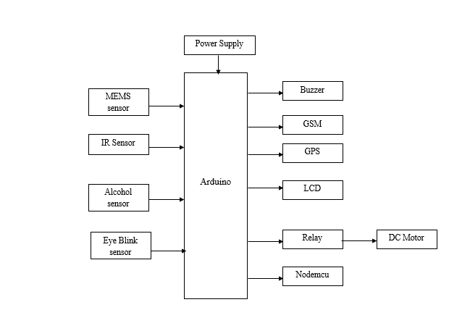
Fig 4.1:- Block Diagram of the project

4.2 EMBEDDED SYSTEM
A schema is a strategy for operational, dealing with or doing one or various endeavors according to a settled orchestrate, package, or set of rules. A skeleton is moreover preparation its chip in as shown by the game plan or venture. For example, consider a watch. It is a period show schema. Its parts are its supplies, needles and battery with the radiant dial, body and strap. These parts make to show the nonstop reliably and continually overhaul the time reliably. The schema framework overhauls the presentation using three needles after consistently. It takes after a set of principles.

Introduction
An inserted framework may be a framework that goes to attempt and do a unimportant assignment is that the connected outline and this level delineated as combo of every machine code and fittings. Generally handy importance of monitor or help the procedure of mechanical assembly, hardware or plant. "Installed" the very truth that partner degree inverse compelling a broadly functional smart phone could likewise be wont to administration the operation of an oversized muddled procedure plant, and its vicinity is self-evident.
All embedded systems square measure as well as computers or microprocessors. A number of these laptops square measure but terribly easy classifications related through private processer. The unpleasantly square measure expressions singularly one performs or set of capacities to fulfill one arranged reason. In extra confounded frameworks partner degree machine developer that permits the installed structure to be used for a picked reason in the midst of a specific application chooses the working of the embedded structure. This is versatility to claim projects imply a near embedded schema is used for an extent of diverse functions. Now and again a microchip could likewise be composed in such somehow that application machine code for a chose reason for existing is quality added to the fundamental machine code amid a second technique, when that its unendurable to structure extra changes.
The most run contraption contains one microchip (habitually intimated as a "chip"), which itself can be prepackaged with unique chips in the midst of a crossbreed structure or application particular microcircuit. Its data starts from a locator or contraption and its yield goes to a switch or substance that could begin or stop the operation of a machine or, by operational a valve, could affiliation the stream of fuel to embellishment degree engine.
Embedded
System

Software
Hardware
- ALP
- C
- VB
Etc.,

- Processor
- Peripherals
- memory
Fig 4.2:- Block diagram of Embedded System

Harvard Architecture
Workstations have separate memory regions for project guidelines and information. There are two or more inside information transports, which permit concurrent access to both directions and information. The CPU gets program directions on the system memory transpose.
The Harvard building design is workstation construction modeling through actually separate stockpiling indicator guidelines from the information. This started hand-off created workstation, put away directions information restricted information stockpiling, completely held inside the focal preparing unit, and gave no right to gain entrance to the direction stockpiling as information.

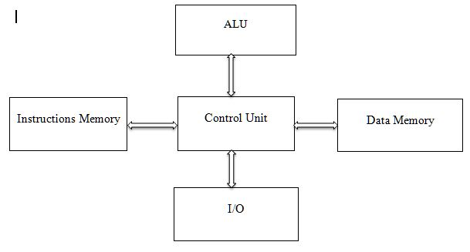
Fig 4.3:- Harvard Architecture

Projects required to be stacked by an administrator, the processor couldn't boot it’s the important playing point of the immaculate Harvard structural planning - synchronous framework decreased by adjusted utilizing current central processing unit store frameworks. Moderately immaculate Harvard building design machines are utilized generally within applications where tradeoffs, for example, the expense and force funds from excluding reserves, exceed punishments different code and information location places.
Von-Neumann Architecture
A machine has a solitary, basic memory space in which both project guidelines and information are put away. There is a solitary inside information transport that gets both directions and information. They can't be performed in the meantime
The Von Neumann construction modeling is an outline model for a put away program computerized workstation that is use a focal preparing unit control processing unit and a solitary separate stockpiling structure ("memory") to clasp both guidelines and information. This is machine researcher machines actualize an all-inclusive Turing machine and have a consecutive structural engineering. The expressions "von Neumann structural engineering" and "put away program workstation" are for the most part utilized conversely, and that utilization is followed in this article.
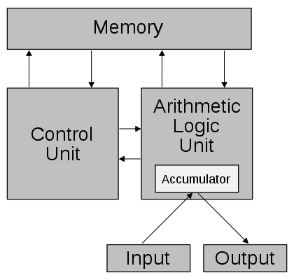
Fig 4.4:- Von-Neumann Architecture
The systems for exchanging the information and directions between the CPU and memory are, be that as it may, extensively more unpredictable than the first von Neumann structural planning.
4.3 Hardware components
Arduino:
Arduino Uno is a very valuable addition in the electronics that consists of USB interface, 14 digital I/O pins, 6 analog pins, and Atmega328 microcontroller. It also supports serial communication using Tx and Rx pins.
There are many versions of Arduino boards introduced in the market like Arduino Uno, Arduino Due, Arduino Leonardo, Arduino Mega, however, most common versions are Arduino Uno and Arduino Mega. If you are planning to create a project relating to digital electronics, embedded system, robotics, or IoT, then using Arduino Uno would be the best, easy and most economical option.
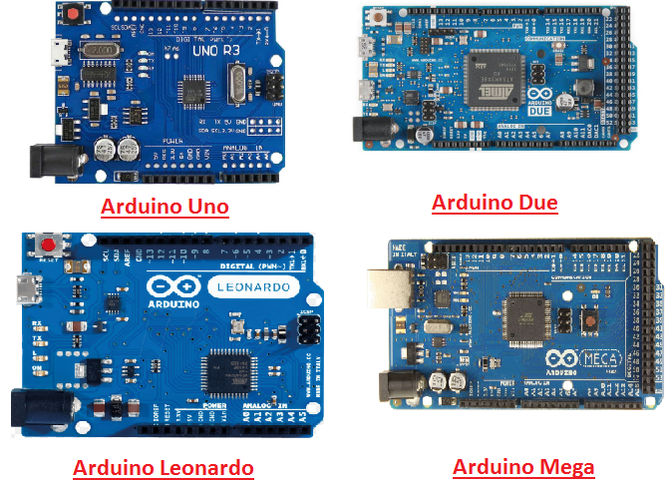
Fig 4.5 Arduino Types
It is an open-source platform, means the boards and software are readily available and anyone can modify and optimize the boards for better functionality. The software used for Arduino devices is called IDE (Integrated Development Environment) which is free to use and required some basic skills to learn it. It can be programmed using C and C++ language. Some people get confused between Microcontroller and Arduino.
later is a board that comes with the microcontroller in the base of the board, bootloader and allows easy access to input-output pins and makes uploading or burning of the program very easy.
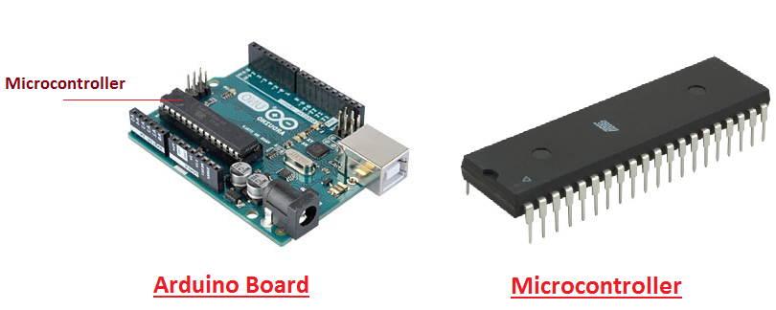
Fig 4.6 Arduino board
While learning microcontroller requires some expertise and skills. Nevertheless, we can say every Arduino is basically a microcontroller but not every microcontroller is an Arduino.
Introduction to Arduino
- Arduino Uno is a microcontroller board developed by Arduino.cc which is an open-source electronics platform mainly based on AVR microcontroller Atmega328.
- First Arduino project was started in Interaction Design Institute Ivrea in 2003 by David Cuartielles and Massimo Banzi with the intention of providing a cheap and flexible way to students and professional for controlling a number of devices in the real world.
- The current version of Arduino Uno comes with USB interface, 6 analog input pins, 14 I/O digital ports that are used to connect with external electronic circuits. Out of 14 I/O ports, 6 pins can be used for PWM output.
- It allows the designers to control and sense the external electronic devices in the real world.
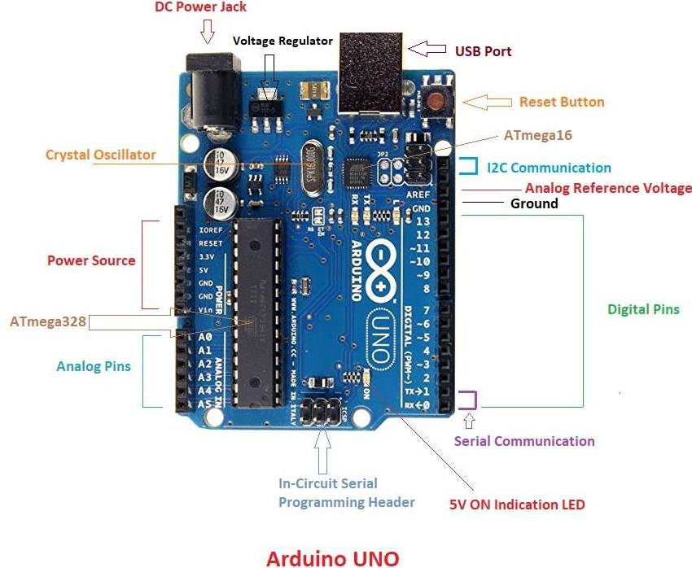
Fig 4.7 Arduino UNO

Arduino Uno is programmed using Arduino Software which a cross-platform application called IDE is written in Java. The AVR microcontroller Atmega328 laid out on the base comes with built-in boot loader that sets you free from using a separate burner to upload the program on the board.
GSM
GSM is a mobile communication modem; it is stands for global system for mobile communication (GSM). The idea of GSM was developed at Bell Laboratories in 1970. It is widely used mobile communication system in the world. GSM is an open and digital cellular technology used for transmitting mobile voice and data services operates at the 850MHz, 900MHz, 1800MHz and 1900MHz frequency bands.GSM system was developed as a digital system using time division multiple access (TDMA) technique for communication purpose. A GSM digitizes and reduces the data, then sends it down through a channel with two different streams of client data, each in its own particular time slot. The digital system has an ability to carry 64 kbps to 120 Mbps of data rates.

GSM Architecture
A GSM network consists of the following components:
- A Mobile Station: It is the mobile phone which consists of the transceiver, the display and the processor and is controlled by a SIM card operating over the network.
- Base Station Subsystem: It acts as an interface between the mobile station and the network subsystem. It consists of the Base Transceiver Station which contains the radio transceivers and handles the protocols for communication with mobiles. It also consists of the Base Station Controller which controls the Base Transceiver station and acts as a interface between the mobile station and mobile switching centre.
- Network Subsystem: It provides the basic network connection to the mobile stations. The basic part of the Network Subsystem is the Mobile Service Switching Centre which provides access to different networks like ISDN, PSTN etc. It also consists of the Home Location Register and the Visitor Location Register which provides the call routing and roaming capabilities of GSM. It also contains the Equipment Identity Register which maintains an account of all the mobile equipment where in each mobile is identified by its own IMEI number. IMEI stands for International Mobile Equipment Identity.

Features of GSM Module:
- Improved spectrum efficiency
- International roaming
- Compatibility with integrated services digital network (ISDN)
- Support for new services.
- SIM phonebook management
- Fixed dialing number (FDN)
- Real time clock with alarm management
- High-quality speech
- Uses encryption to make phone calls more secure

GSM Modem
A GSM modem is a device which can be either a mobile phone or a modem device which can be used to make a computer or any other processor communicate over a network. A GSM modem requires a SIM card to be operated and operates over a network range subscribed by the network operator. It can be connected to a computer through serial, USB or Bluetooth connection.
A GSM modem can also be a standard GSM mobile phone with the appropriate cable and software driver to connect to a serial port or USB port on your computer. GSM modem is usually preferable to a GSM mobile phone. The GSM modem has wide range of applications in transaction terminals, supply chain management, security applications, weather stations and GPRS mode remote data logging.
Fig 4.8 GSM modem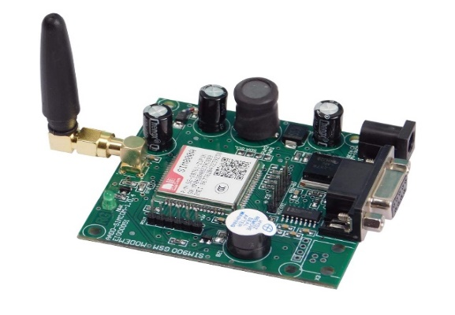
It requires a SIM (Subscriber Identity Module) card just like mobile phones to activate communication with the network. Also they have IMEI (International Mobile Equipment Identity) number similar to mobile phones for their identification. A GSM/GPRS MODEM can perform the following operations:
1. Receive, send or delete SMS messages in a SIM.
2. Read, add, search phonebook entries of the SIM.
3. Make, Receive, or reject a voice call.
The MODEM needs AT commands, for interacting with processor or controller, which are communicated through serial communication. These commands are sent by the controller/processor. The MODEM sends back a result after it receives a command. Different AT commands supported by the MODEM can be sent by the processor/controller/computer to interact with the GSM and GPRS cellular network.
6.3 Power supply:
A power supply is a component that provides at least one electrical charge with power. It typically converts one type of electrical power to another, but it can also convert a different Energy form in electrical energy, such as solar, mechanical, or chemical.
A power supply provides electrical power to components. Usually the term refers to devices built into the powered component. Computer power supplies, for example, convert AC current to DC current and are generally located along with at least one fan at the back of the computer case.
Most computer power supplies also have an input voltage switch that, depending on the geographic location, can be set to 110v/115v or 220v/240v. Due to the different power voltages supplied by power outlets in different countries, this switch position is crucial.
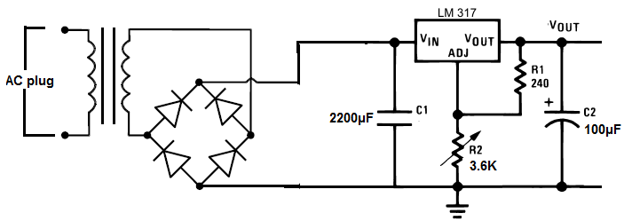
Fig 4.9 Power supply
IR sensor:
An infrared sensor is an electronic device, which emits in order to sense some aspects of the surroundings. An IR sensor can measure the heat of an object as well as detects the motion. These types of sensors measures only infrared radiation, rather than emitting it that is called as a passive IR sensor. Usually in the infrared spectrum, all the objects radiate some form of thermal radiations. These types of radiations are invisible to our eyes, which can be detected by an infrared sensor. The emitter is simply an IR LED (Light Emitting Diode) and the detector is simply an IR photodiode which is sensitive to IR light of the same wavelength as that emitted by the IR LED. When IR light falls on the photodiode, the resistances and these output voltages, change in proportion to the magnitude of the IR light received.

IR Transmitter
IR Transmitter acts as source for IR radiation. According to Plank’s Radiation Law, every object is a source of IR radiation at temp T above 0 Kelvin. In most cases black body radiators, tungsten lamps, silicon carbide, infrared lasers, LEDs of infrared wavelength are used as sources.

Transmission Medium
As the name suggests, Transmission Medium provides passage for the radiation to reach from IR Transmitter to IR Receiver. Vacuum, atmosphere and optical fibers are used as medium.

IR receiver
Generally IR receivers are photo diode and photo transistors. They are capable of detecting infrared radiation. Hence IR receiver is also called as IR detector. Variety of receivers are available based on wavelength, voltage and package.
IR Transmitter and Receivers are selected with matching parameters. Some of deciding specifications of receivers are photosensitivity or responsivity, noise equivalent power and detectivity.

How Infrared Sensor Works
- IR source (transmitter) is used to emit radiation of required wavelength.
- This radiation reaches the object and is reflected back.
- The reflected radiation is detected by the IR receiver.
- The IR Receiver detected radiation is then further processed based on its intensity. Generally, IR Receiver output is small and amplifiers are used to amplify the detected signal.
Typical working of IR sensor detection system can be understood by Figure 2 below.
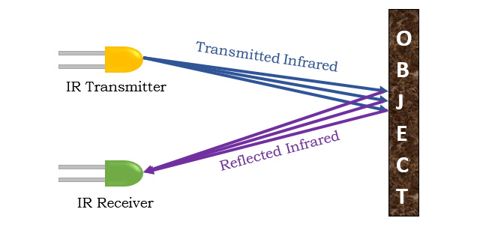
Fig 4.10: How Infrared Sensor Works
Incidence in an IR Detection System may be direct or indirect. In case of Direct Incidence, there is no hindrance in between transmitter and receiver. Whereas, in Indirect Incidence IR Transmitter and Receiver are kept side by side and the object is in front of them.
MEMS Sensor:
The term MEMS stands for micro-electro-mechanical systems. These are a set of devices, and the characterization of these devices can be done by their tiny size & the designing mode. The designing of these sensors can be done with the 1- 100-micrometer components. These devices can differ from small structures to very difficult electromechanical systems with numerous moving elements beneath the control of incorporated micro-electronics. Usually, these sensors include mechanical micro-actuators, micro-structures, micro-electronics, and micro-sensors in one package. This article discusses what is a MEMS sensor, working principle, advantages and it’s applications

What is a MEMS Sensor?
MEMS are low-cost, and high accuracy inertial sensors and these are used to serve an extensive range of industrial applications. This sensor uses a chip-based technology namely micro-electro-mechanical-system. These sensors are used to detect as well as measure the external stimulus like pressure, after that it responds to the pressure which is measured pressure with the help of some mechanical actions. The best examples of this mainly include revolving of a motor for compensating the pressure change.
The MEMS accelerometers can be divided into two important micro system architectures: piezo resistive and capacitive. Even though both of these two types of accelerometers possess internal proof masses which are excited by acceleration, the differences of these two architectures lie in the transduction mechanism which is used to the movement correlation of the internal proof mass to accelerate.
The Capacitive accelerometers possess a differential capacitor whose balance is disrupted by the proof mass movement. Piezo resistive accelerometers commonly rely on inducing, which attach the proof mass to the sensor which is used for identification of the movement of the mass. Fujitsu successfully developed the ‘FAR-S2AB’ series, 3-axis Accelerometer, using state-of-the-art MEMS technology. This small and highly sensitive accelerometer can detect acceleration, inclination and vibration by measuring the motion in the x-, y-, and z-axis simultaneously. The MEMS 3-axis accelerometer consists of a Mass at the center of the sensor’s chip, which is suspended by 4 Beams doped with Piezo resistive material.
By sensing the mounting angle, the sensor can assist in compensating for the devices mounting angle, and therefore makes it possible to use ACCELEROMETER FACTSHEET MEMS 3-AXIS ACCELEROMETER normal SMD technology in high density boards, and also to realize the precise detection of the inclination angle. An interface IC within the sensor package also has temperature sensing and self-diagnosis functions.
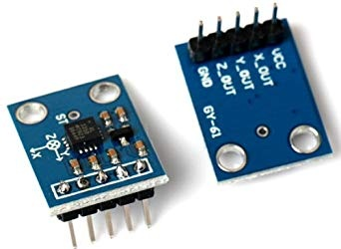
Fig 4.11 MEMS Sensor
GPS:
Global Positioning System (GPS) is a satellite-based system that uses satellites and ground stations to measure and compute its position on Earth.
GPS is also known as Navigation System with Time and Ranging (NAVSTAR) GPS.
GPS receiver needs to receive data from at least 4 satellites for accuracy purpose. GPS receiver does not transmit any information to the satellites.
How GPS Works
GPS receiver uses a constellation of satellites and ground stations to calculate accurate location wherever it is located.
These GPS satellites transmit information signal over radio frequency.
GPS Module
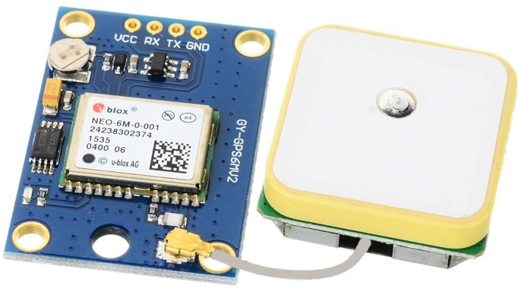
Fig 4.12 GPS Receiver
GPS receiver module gives output in standard (National Marine Electronics Association) NMEA string format. It provides output serially on Tx pin with default 9600 Baud rate.
This NMEA string output from GPS receiver contains different parameters separated by commas like longitude, latitude, altitude, time etc. Each string starts with ‘$’ and ends
To do this, connect this GPS module to the PC via USB to Serial converter or DB9 connector. Also, it is necessary to keep antenna of GPS module on proper location.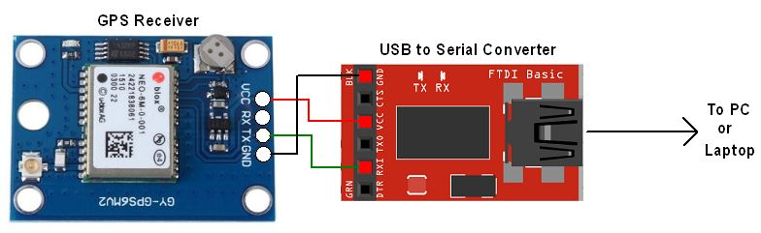
Fig 4.13 GPS Serial Interface

In the above string, the NMEA string starting with “$GPGGA” is most popularly used. It provides us Time, Longitude, Latitude and Altitude along with directions. This information is helpful to find Time and Location.

DC Motor

A direct current (DC) motor is a type of electric machine that converts electrical energy into mechanical energy. DC motors take electrical power through direct current, and convert this energy into mechanical rotation. DC motors use magnetic fields that occur from the electrical currents generated, which powers the movement of a rotor fixed within the output shaft. The output torque and speed depends upon both the electrical input and the design of the motor.

DC motors include two key components: a stator and an armature. The stator is the stationary part of a motor, while the armature rotates. In a DC motor, the stator provides a rotating magnetic field that drives the armature to rotate.

A simple DC motor uses a stationary set of magnets in the stator, and a coil of wire with a current running through it to generate an electromagnetic field aligned with the centre of the coil. One or more windings of insulated wire are wrapped around the core of the motor to concentrate the magnetic field.

The windings of insulated wire are connected to a commutator (a rotary electrical switch), that applies an electrical current to the windings. The commutator allows each armature coil to be energized in turn, creating a steady rotating force (known as torque).

When the coils are turned on and off in sequence, a rotating magnetic field is created that interacts with the differing fields of the stationary magnets in the stator to create torque, which causes it to rotate.
Fig 4.14 DC Motor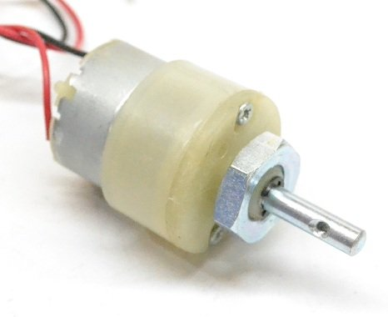
Buzzer:
A buzzer or beeper is an audio signaling device, which may be mechanical, electromechanical, or piezoelectric. Typical uses of buzzers and beepers include alarm devices, timers and confirmation of user input such as a mouse click or keystroke. Buzzer is an integrated structure of electronic transducers, DC power supply, widely used in computers, printers, copiers, alarms, electronic toys, automotive electronic equipment, telephones, timers and other electronic products for sound devices. Active buzzer 5V Rated power can be directly connected to a continuous sound, this section dedicated sensor expansion module and the board in combination, can complete a simple circuit design, to "plug and play.
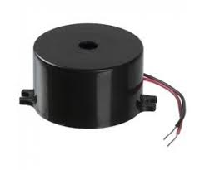

Fig 4.15 Buzzer

Buzzer Pin Configuration
Pin Number | Pin Name | Description
1 | Positive | Identified by (+) symbol or longer terminal lead. Can be powered by 5V DC
2 | Negative | Identified by short terminal lead. Typically connected to the ground of the circuit

How to use a Buzzer
A buzzer is a small yet efficient component to add sound features to our project/system. It is very small and compact 2-pin structure hence can be easily used on breadboard, Perf Board and even on PCBs which makes this a widely used component in most electronic applications.
There are two types are buzzers that are commonly available. The one shown here is a simple buzzer which when powered will make a Continuous Beeeeeeppp.... sound, the other type is called a readymade buzzer which will look bulkier than this and will produce a Beep. Beep. Beep. Sound due to the internal oscillating circuit present inside it. But, the one shown here is most widely used because it can be customized with help of other circuits to fit easily in our application.
This buzzer can be used by simply powering it using a DC power supply ranging from 4V to 9V. A simple 9V battery can also be used, but it is recommended to use a regulated +5V or +6V DC supply. The buzzer is normally associated with a switching circuit to turn ON or turn OFF the buzzer at required time and require interval.
Applications of Buzzer
- Alarming Circuits, where the user has to be alarmed about something
- Communication equipment’s
- Automobile electronics
- Portable equipment’s, due to its compact size
LCD:
- LCD (Liquid Crystal Display) is the innovation utilized in scratch pad shows and other littler PCs. Like innovation for light-producing diode (LED) and gas-plasma, LCDs permit presentations to be a lot more slender than innovation for cathode beam tube (CRT). LCDs expend considerably less power than LED shows and gas shows since they work as opposed to emanating it on the guideline of blocking light.
- A LCD is either made with a uninvolved lattice or a showcase network for dynamic framework show. Likewise alluded to as a meager film transistor (TFT) show is the dynamic framework LCD. The uninvolved LCD lattice has a matrix of conductors at every crossing point of the network with pixels. Two conductors on the lattice send a current to control the light for any pixel. A functioning framework has a transistor situated at every pixel crossing point, requiring less current to control the luminance of a pixel.
- Some aloof network LCD's have double filtering, which implies they examine the matrix twice with current in the meantime as the first innovation took one sweep. Dynamic lattice, be that as it may, is as yet a higher innovation.
- A 16x2 LCD show is an essential module that is generally utilized in various gadgets and circuits. These modules more than seven sections and other multi fragment LEDs are liked. The reasons being: LCDs are affordable; effectively programmable; have no restriction of showing exceptional and even custom characters (not at all like in seven fragments), movements, etc.
- A 16x2 LCD implies 16 characters can be shown per line and 2 such lines exist. Each character is shown in a lattice of 5x7 pixels in this LCD. There are two registers in this LCD, in particular Command and Data.
- The directions given to the LCD are put away by the order register. An order is a direction given to LCD to play out a predefined assignment, for example, introducing it, clearing its screen, setting the situation of the cursor, controlling presentation, and so forth. The information register will store the information that will be shown on the LCD. The information is the character's ASCII incentive to show on the LCD.

Data/Signals/Execution of LCD
- Now that was all about the signals and the hardware. Let us come to data, signals and execution.
- Two types of signals are accepted by LCD, one is data and one is control. The LCD module recognizes these signals from the RS pin status. By pulling the R / W pin high, data can now also be read from the LCD display. Once the E pin has been pulsed, the LCD display reads and executes data at the falling edge of the pulse, the same for the transmission case.
- It takes 39-43μS for the LCD display to place a character or execute a command. It takes 1.53ms to 1.64ms except for clearing display and searching for cursor to the home position.
- Any attempt to send data before this interval may result in failure in some devices to read data or execute the current data. Some devices compensate for the speed by storing some temporary registers with incoming data.
- There are two RAMs for LCD displays, namely DDRAM and CGRAM. DDRAM registers the position in which the character would be displayed in the ASCII chart. Each DDRAM byte represents every single position on the display of the LCD.
- The DDRAM information is read by the LCD controller and displayed on the LCD screen. CGRAM enables users to define their personalized characters. Address space is reserved for users for the first 16 ASCII characters.
- Users can easily display their custom characters on the LCD screen after CGRAM has been set up to display characters.
- Images of LCD Display:-
- 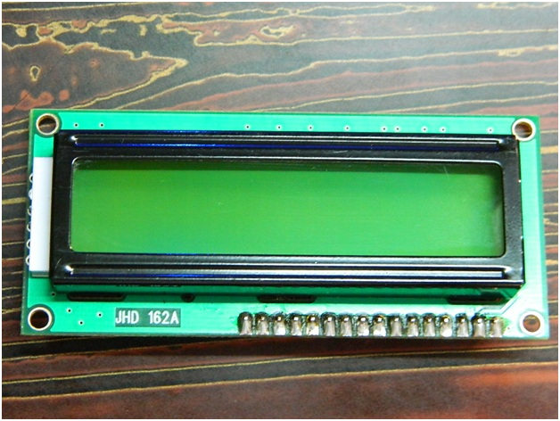
- LCD – Front View
- 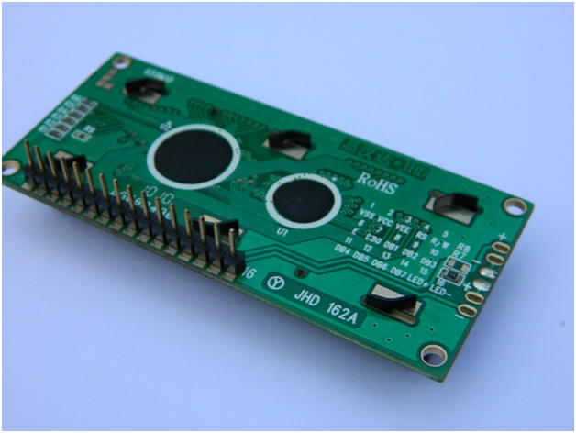
- LCD – Back View
- Pin Diagram:

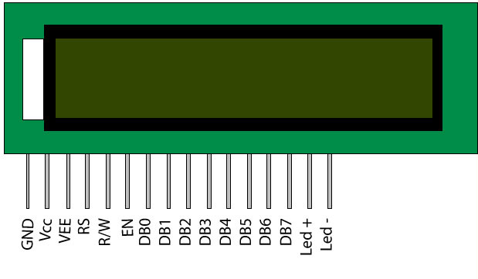

Fig 4.16 LCD Display
- Pin Description:
Pin No | Function | Name
1 | Ground (0V) | Ground
2 | Supply voltage; 5V (4.7V – 5.3V) | Vcc
3 | Contrast adjustment; through a variable resistor | V_{EE}
4 | Selects command register when low; and data register when high | Register Select
5 | Low to write to the register; High to read from the register | Read/write
6 | Sends data to data pins when a high to low pulse is given | Enable
7 | 8-bit data pins | DB0
8 | 8-bit data pins | DB1
9 | 8-bit data pins | DB2
10 | 8-bit data pins | DB3
11 | 8-bit data pins | DB4
12 | 8-bit data pins | DB5
13 | 8-bit data pins | DB6
14 | 8-bit data pins | DB7
15 | Backlight V_{CC} (5V) | Led+
16 | Backlight Ground (0V) | Led-

LCD Commands:
- There are some preset commands in the LCD that we need to send to the LCD via some microcontroller. The following are some important command instructions:
Sr. No. | Hex Code | Command to LCD instruction Register
1 | 01 | Clear display screen
2 | 02 | Return home
3 | 04 | Decrement cursor (shift cursor to left)
4 | 06 | Increment cursor (shift cursor to right)
5 | 05 | Shift display right
6 | 07 | Shift display left
7 | 08 | Display off, cursor off
8 | 0A | Display off, cursor on
9 | 0C | Display on, cursor off
10 | 0E | Display on, cursor blinking
11 | 0F | Display on, cursor blinking
12 | 10 | Shift cursor position to left
13 | 14 | Shift cursor position to right
14 | 18 | Shift the entire display to the left
15 | 1C | Shift the entire display to the right
16 | 80 | Force cursor to beginning ( 1st line)
17 | C0 | Force cursor to beginning ( 2nd line)
18 | 38 | - lines and 5×7 matrix

Command codes for LCD

Block Diagram of LCD Display:-

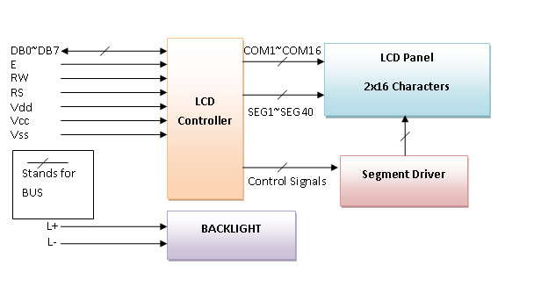
- Control and display commands
Instruction | Instruction Code |  |  |  |  |  |  |  |  |  | Instruction Code Description | Execution time
Instruction | RS | R/W | DB7 | DB6 | DB5 | DB4 | DB3 | DB2 | DB1 | DB0 | Instruction Code Description | Execution time
Read Data From RAM | 1 | 1 | D7 | D6 | D5 | D4 | D3 | D2 | D1 | D0 | Read data from internal RAM | 1.53-1.64ms
Write data to RAM | 1 | 0 | D7 | D6 | D5 | D4 | D3 | D2 | D1 | D0 | Write data into internal RAM (DDRAM/CGRAM) | 1.53-1.64ms
Busy flag & Address | 0 | 1 | BF | AC6 | AC5 | AC4 | AC3 | AC2 | AC1 | AC0 | Busy flag (BF: 1→ LCD Busy) and contents of address counter in bits AC6-AC0. | 39 µs
Set DDRAM Address | 0 | 0 | 1 | AC6 | AC5 | AC4 | AC3 | AC2 | AC1 | AC0 | Set DDRAM address in address counter. | 39 µs
Set CGRAM Address | 0 | 0 | 0 | 1 | AC5 | AC4 | AC3 | AC2 | AC1 | AC0 | Set CGRAM Address in address counter. | 39 µs
Function Set | 0 | 0 | 0 | 0 | 1 | DL | N | F | X | X | Set interface data length (DL: 4bit/8bit), Numbers of display line (N: 1-line/2-line) display font type (F:0→ 5×8 dots, F:1→ 5×11 dots) | 39 µs
Cursor or Display Shift | 0 | 0 | 0 | 0 | 0 | 1 | S/C | R/L | X | X | Set cursor moving and display shift control bit, and the direction without changing DDRAM data | 39 µs
Display & Cursor On/Off | 0 | 0 | 0 | 0 | 0 | 0 | 1 | D | C | B | Set Display(D),Cursor(C) and cursor blink(b) on/off control | 39 µs
Entry Mode Set | 0 | 0 | 0 | 0 | 0 | 0 | 0 | 1 | I/D | SH | Assign cursor moving direction and enable shift entire display. | 0µs
Return Home | 0 | 0 | 0 | 0 | 0 | 0 | 0 | 0 | 1 | X | Set DDRAM Address to “00H” from AC and return cursor to its original position if shifted. | 43µs
Clear Display | 0 | 0 | 0 | 0 | 0 | 0 | 0 | 0 | 0 | 1 | Write “20H” to DDRAM and set DDRAM Address to “00H” from AC | 43µs
4-bit and 8-bit Mode of LCD:
- The LCD can work in two striking modes, the 4-bit mode and the 8-bit mode. We send the information snack through snack in 4 bit mode, first upper chomp, by then lower snack. For those of you who don't have the foggiest idea what a goody is: a chomp is a four-piece gathering, so a byte's lower four bits (D0-D3) are the lower snack, while a byte's upper four bits (D4-D7) are the higher snack. This enables us to send 8 bit data. This connects with us to send 8 bit data. Whereas in 8 bit mode we can send the 8-bit information truly in one stroke since we utilize all the 8 information lines. You need to get it now; yes 8-bit mode is quicker and immaculate than 4-bit mode. In any case, the fundamental shortcoming is that it needs 8 microcontroller-related information lines. This will result in our MCU coming up short on I/O pins, so 4-bit mode is extensively utilized. To set these modes, no control pins are used.
MQ3 SENSOR:
The MQ3 sensor is one of the most widely used in the MQ sensor series. It is a MOS (Metal Oxide Semiconductor) sensor. Metal oxide sensors are also known as Chemiresistors because sensing is based on the change in resistance of the sensing material when exposed to alcohol.
The MQ3 is a heater-driven sensor. It is therefore covered with two layers of fine stainless steel mesh known as an “anti-explosion network”. It ensures that the heater element inside the sensor does not cause an explosion because we are sensing flammable gas (alcohol).
When the outer mesh is removed, the sensor looks like this. The sensing element and six connecting legs that extend beyond the Bakelite base form the star-shaped structure. Two (H) of the six leads are in charge of heating the sensing element and are linked together by a Nickel-Chromium coil (a well-known conductive alloy).When a SnO2 semiconductor layer is heated to a high temperature, oxygen is adsorbed on the surface. When the air is clean, electrons from the conduction band of tin dioxide are attracted to oxygen molecules. This creates an electron depletion layer just beneath the surface of the SnO2 particles, forming a potential barrier.
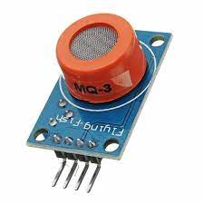
Fig 4.21 MQ3 Sensor
Relay
A relay is an electromagnetic switch that is used to turn on and turn off a circuit by a low power signal, or where several circuits must be controlled by one signal. Most of the high end industrial application devices have relays for their effective working. Relays are simple switches which are operated both electrically and mechanically. Relays consist of an electromagnet and also a set of contacts. The switching mechanism is carried out with the help of the electromagnet. There are also other operating principles for its working. But they differ according to their applications. Most of the devices have the application of relays.
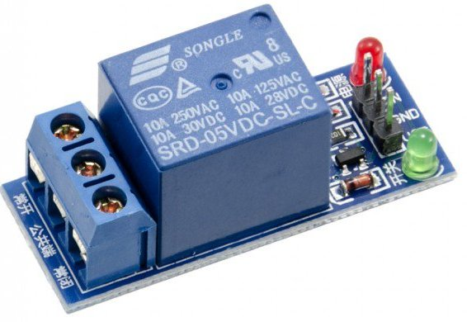 Fig 4.22 Relay
Why is a relay used?
The main operation of a relay comes in places where only a low-power signal can be used to control a circuit. It is also used in places where only one signal can be used to control a lot of circuits. The application of relays started during the invention of telephones. They played an important role in switching calls in telephone exchanges. They were also used in long distance telegraphy. They were used to switch the signal coming from one source to another destination. After the invention of computers they were also used to perform Boolean and other logical operations. The high end applications of relays require high
As soon as the coil current is off, the movable armature will be returned by a force back to its initial position. This force will be almost equal to half the strength of the magnetic force. This force is mainly provided by two factors. They are the spring and also gravity.

Relay Applications
- A relay circuit is used to realize logic functions. They play a very important role in providing safety critical logic.
- Relays are used to provide time delay functions. They are used to time the delay open and delay close of contacts.
- Relays are used to control high voltage circuits with the help of low voltage signals. Similarly they are used to control high current circuits with the help of low current signals.
- They are also used as protective relays. By this function all the faults during transmission and reception can be detected and isolated.
NodeMCU:
Node MCU is an open-source firmware and development kit that plays a vital role in designing your own IoT product using a few Lua script lines.
Multiple GPIO pins on the board allow you to connect the board with other peripherals and are capable of generating PWM, I2C, SPI, and UART serial communications.
- The interface of the module is mainly divided into two parts including both Firmware and Hardware where former runs on the ESP8266 Wi-Fi SoC and later is based on the ESP-12 module.
- USB to UART converter is added on the module that helps in converting USB data to UART data which mainly understands the language of serial communication.
- The board incorporates status LED that blinks and turns off immediately, giving you the current status of the module if it is running properly when connected with the computer.
How to Power NodeMCU
USB Power. It proves to an ideal choice for loading programs unless the project you aim to design requires separate interface i.e. disconnected from the computer.
Provide 3.3V. This is another great option to power up the module. If you have your own off-board regulator, you can generate an instant power source for your development kit.
Power Vin. This is a voltage regulator that comes with the ability to support up to 800 mA. It can handle somewhere between 7 to 12 V. You cannot power the devices operating at 3.3 V, as this regulator unable to generate as low as 3.3V.
Applications:
- Internet Smoked Alarm
- VR Tracker
- Octopod
- Serial Port Monitor
- ESP Lamp
- Incubator Controller
- IoT home automation
- Security Alarms
4.4 Software Components
Arduino IDE:
Arduino IDE where IDE stands for Integrated Development Environment – An official software introduced by Arduino.cc, that is mainly used for writing, compiling and uploading the code in the Arduino Device. Almost all Arduino modules are compatible with this software that is an open source and is readily available to install and start compiling the code on the go.
How to install Arduino IDE:
You can download the Software from Arduino main website. As I said earlier, the software is available for common operating systems like Linux, Windows, and MAX, so make sure you are downloading the correct software version that is easily compatible with your operating system.
- If you aim to download Windows app version, make sure you have Windows 8.1 or Windows 10, as app version is not compatible with Windows 7 or older version of this operating system.
The IDE environment is mainly distributed into three sections
- 1. Menu Bar
- 2. Text Editor
- 3. Output Pane
As you download and open the IDE software, it will appear like an image below.
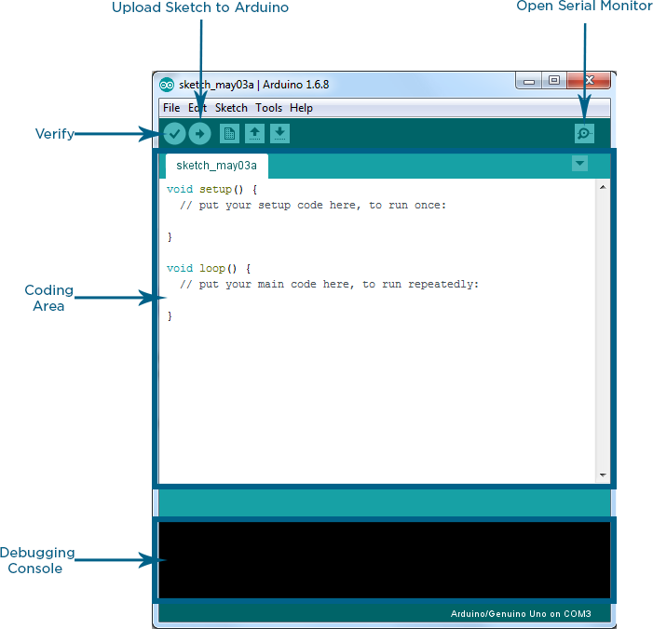
The bar appearing on the top is called Menu Bar that comes with five different options as follow
- File – You can open a new window for writing the code or open an existing one. Following table shows the number of further subdivisions the file option is categorized into.
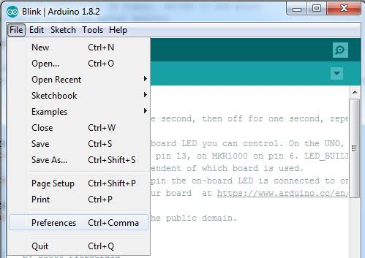
As you go to the preference section and check the compilation section, the Output Pane will show the code compilation as you click the upload button.
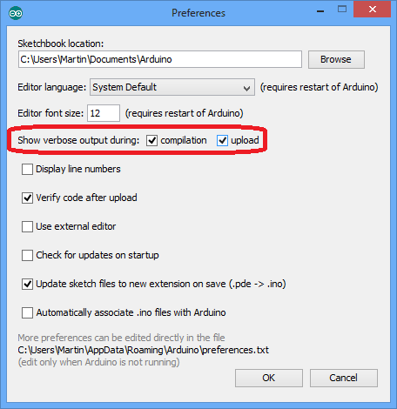
And at the end of compilation, it will show you the hex file it has generated for the recent sketch that will send to the Arduino Board for the specific task you aim to achieve.
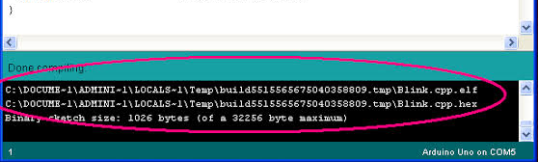
- Edit – Used for copying and pasting the code with further modification for font
- Sketch – For compiling and programming
- Tools – Mainly used for testing projects. The Programmer section in this panel is used for burning a bootloader to the new microcontroller.
- Help – In case you are feeling skeptical about software, complete help is available from getting started to troubleshooting.
The Six Buttons appearing under the Menu tab are connected with the running program as follow.
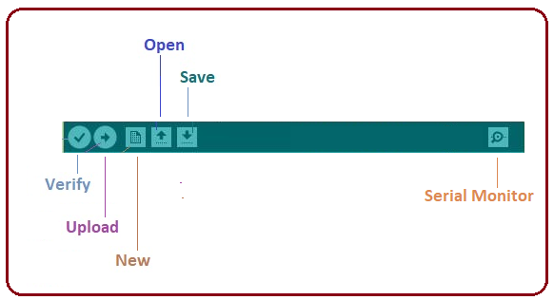
- The check mark appearing in the circular button is used to verify the code. Click this once you have written your code.
- The arrow key will upload and transfer the required code to the Arduino board.
- The dotted paper is used for creating a new file.
- The upward arrow is reserved for opening an existing Arduino project.
- The downward arrow is used to save the current running code.
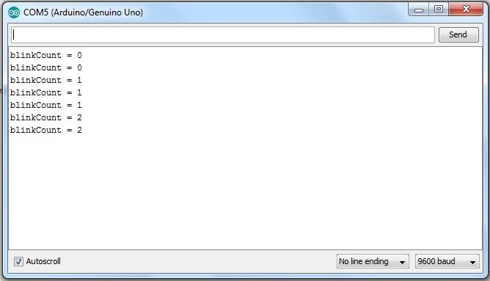

The main screen below the Menu bard is known as a simple text editor used for writing the required code.
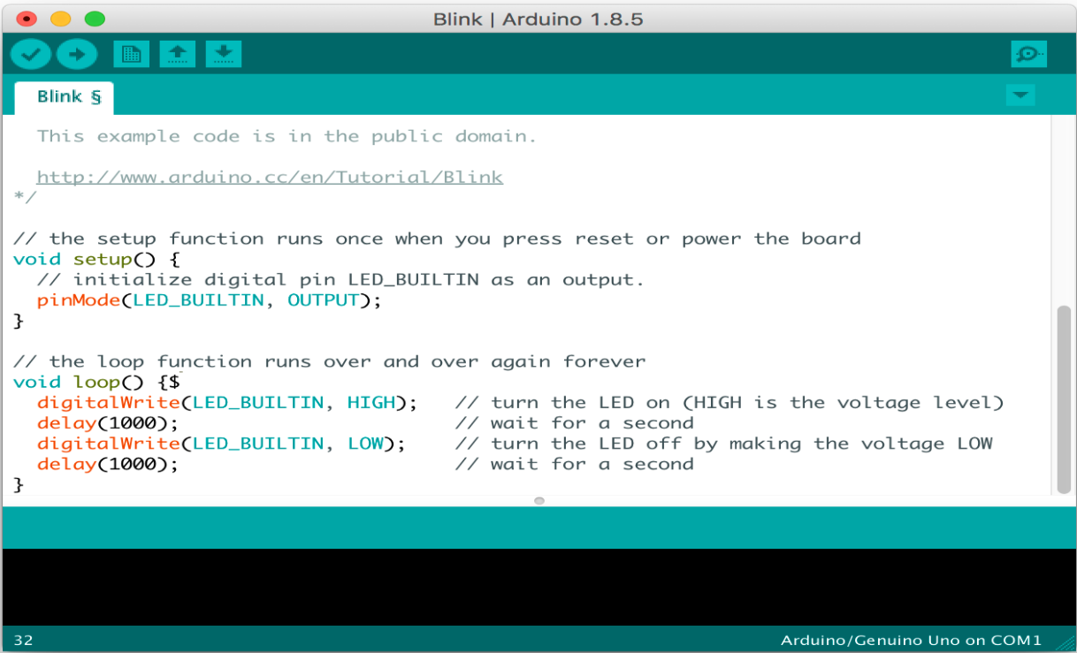
The bottom of the main screen is described as an Output Pane that mainly highlights the compilation status of the running code: the memory used by the code, and errors occurred in the program. You need to fix those errors before you intend to upload the hex file into your Arduino Module.
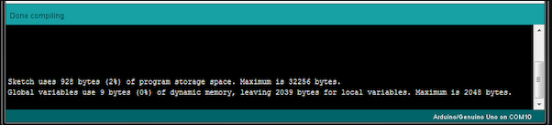
More or less, Arduino C language works similar to the regular C language used for any embedded system microcontroller, however, there are some dedicated libraries used for calling and executing specific functions on the board.

Libraries:
Libraries are very useful for adding the extra functionality into the Arduino Module. There is a list of libraries you can add by clicking the Sketch button in the menu bar and going to Include Library.
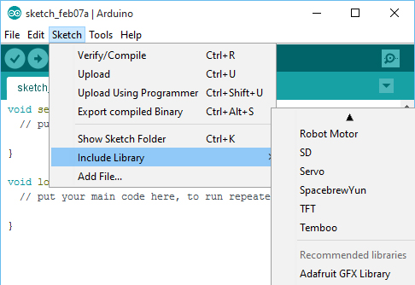
As you click the Include Library and Add the respective library it will on the top of the sketch with a #include sign. Suppose, I Include the EEPROM library, it will appear on the text editor as
#include <EEPROM.h>.
Most of the libraries are preinstalled and come with the Arduino software. However, you can also download them from the external sources.

How to select the board:
In order to upload the sketch, you need to select the relevant board you are using and the ports for that operating system. As you click the Tools on the Menu, it will open like the figure below.
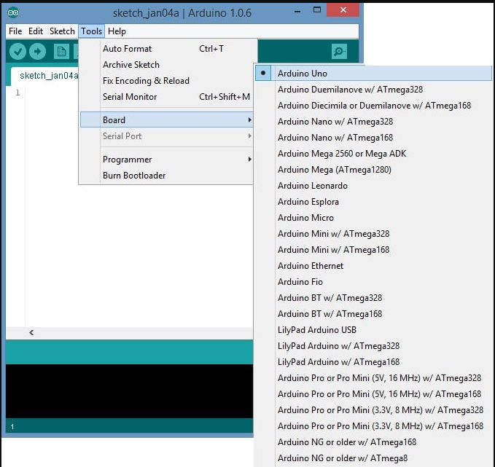
- Just go to the “Board” section and select the board you aim to work on. Similarly, COM1, COM2, COM4, COM5, COM7 or higher are reserved for the serial and USB board. You can look for the USB serial device in the ports section of the Windows Device Manager.
Following figure shows the COM4 that I have used for my project, indicating the Arduino Uno with COM4 port at the right bottom corner of the screen.
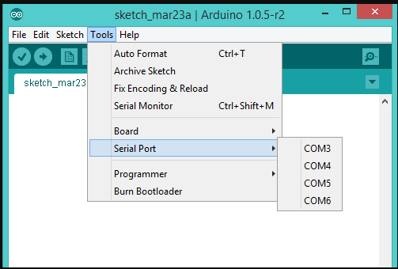
- After correct selection of both Board and Serial Port, click the verify and then upload button appearing in the upper left corner of the six button section or you can go to the Sketch section and press verify/compile and then upload.
- The sketch is written in the text editor and is then saved with the file extension .ino.
It is important to note that the recent Arduino Modules will reset automatically as you compile and press the upload button the IDE software, however, older version may require the physical reset on the board.
- Once you upload the code, TX and RX LEDs will blink on the board, indicating the desired program is running successfully.
Note: The port selection criteria mentioned above is dedicated for Windows operating system only, you can check this Guide if you are using MAC or Linux.
- The amazing thing about this software is that no prior arrangement or bulk of mess is required to install this software, you will be writing your first program within 2 minutes after the installation of the IDE environment.
BootLoader:
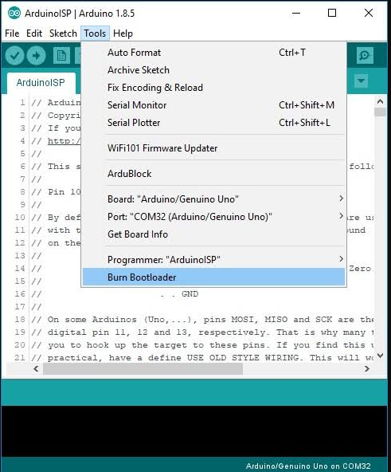
When you buy the new Arduino Module, the bootloader is already installed inside the controller. However, if you intend to buy a controller and put in the Arduino module, you need to burn the bootloader again inside the controller by going to the Tools section and selecting the burn bootloader.
Flow chart
Start

CHAPTER 5
RESULTS AND DISCUSSIONS
Experimental Results
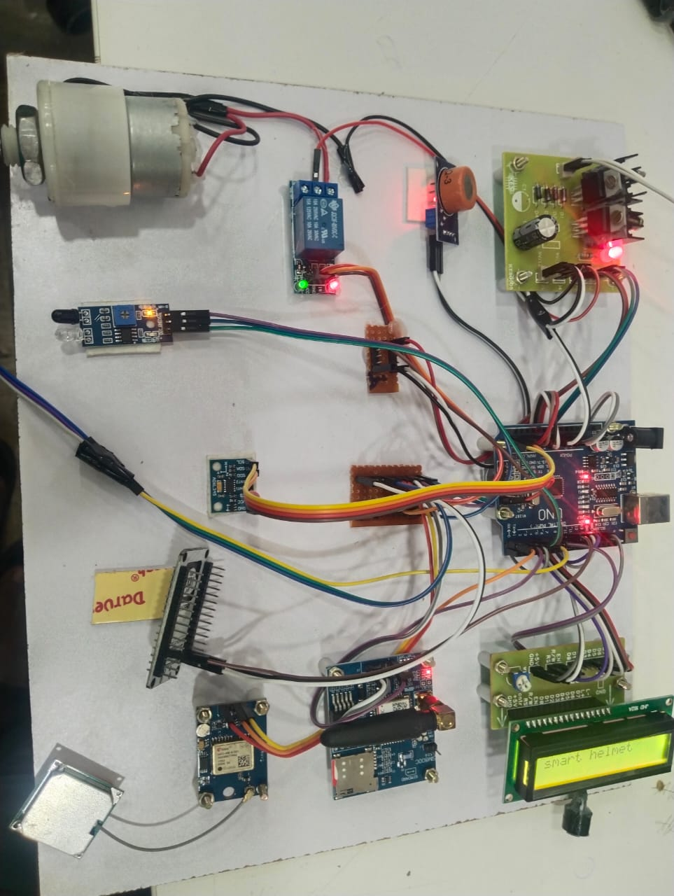
Figure 5.1: Hardware Setup
In the above figure the DC motor starts rotating when the power supply is given. When the rider starts the vehicle the IR sensor identifies the helmet is worn properly or not. MEMS sensor detects the rider fallen or not. Alcohol sensor detects rider consumed alcohol or not. Eye blink sensor moniter rider alertness. The sensors are integrated in Arduino UNO. GPS and GSM help to find the location of the rider. LCD displays the information in abnormal conditions. When an abnormal condition triggers the DC motor turns off automatically.
Results and Discussions
This helmet has IR Sensor to detect whether helmet worn properly or not, MEMS sensor to detect the rider fallen or not, Alcohol sensor to detect whether the rider consumed alcohol or not, an eye blink sensor to monitor rider alertness. abnormal conditions triggers a buzzer alert and deactivate the DC motor via Delay. GPS and GSM modules provide precise location tracking and send emergency notifications.
Step-1: By using Thingspeak app we can moniter helmet conditions and sensor data is sent to Thingspeak via WiFi. If an accident is detected, Thingspeak triggers an alert to emergency contacts. Location data is updated continuously.
- When a rider consumed alcohol the alcohol sensor detects alcohol. Then the information is displayed in the LCD, DC motor turns off automatically.
- The Eye blink sensor moniter rider alertness. When rider closes his eyes for 2 seconds then eye blink sensor will detect and the information is displayed in the LCD.
- The IR sensor identifies whether the rider worn helmet properly or not. If helmet is not worn properly the information is displayed in the LCD.
- The MEMS sensor detects the rider fallen or not. If any sudden jerk or any fallen occurs then the information is displayed in the LCD which turns off the DC motor automatically.

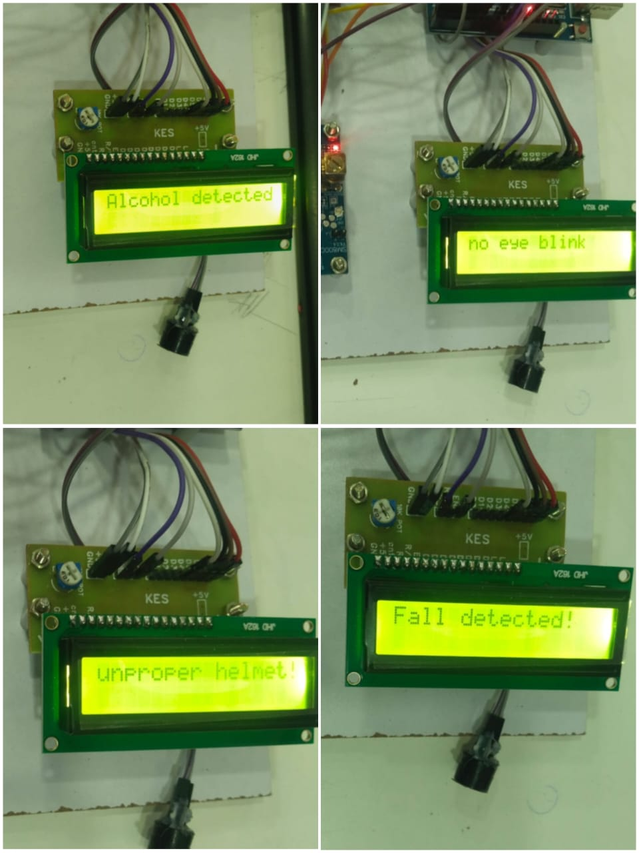
Fig 5.2 Information displayed in LCD

- GPS automatically tracks the location and display latitude and longitude values and information is send to the emergency contacts.

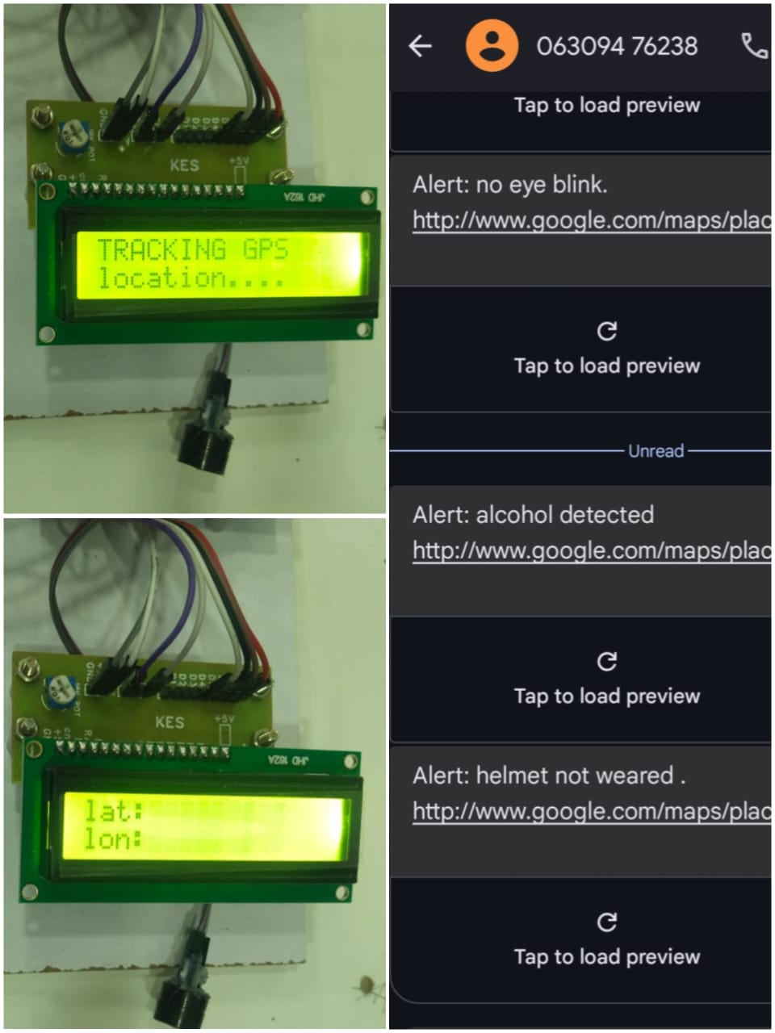

Fig 5.3: Location tracking

CHAPTER 6
ADVANTAGES, DISADVANTAGES & APPLICATIONS

6.1 ADVANTAGES
- Accident detection
- Emergency alerts
- Intoxication prevention
- Enhanced road safety

6.2 DISADVANTAGES
- High cost
- Battery dependency
- Connectivity issues

6.3 APPLICATIONS
- Rider safety systems
- Emergency response systems
- Intelligent transportation
- IoT-enabled smart vehicles
- Road accident prevention

CHAPTER 7
CONCLUSION AND FUTURE SCOPE
7.1 CONCLUSION
The "Smart Helmet for Riders to Avoid Accidents Using IoT" is a cutting-edge safety solution designed to enhance rider security and reduce road accidents through advanced technology. By integrating components such as an Arduino UNO, IR sensor, alcohol sensor, MEMS sensor, eye blink sensor, GPS, and GSM modules, the helmet provides real-time monitoring of rider conditions, including alcohol detection, accident identification, and alertness levels. In case of abnormal conditions, the system triggers a buzzer alert and deactivates the vehicle’s motor, ensuring safe riding. Additionally, the LCD offers real-time safety updates, while GPS and GSM modules send emergency notifications, enabling prompt responses during critical situations. Leveraging IoT technology, this smart helmet not only prevents unsafe vehicle operation but also significantly improves road safety by enabling swift interventions and protecting riders from potential accidents.
7.2 FUTURE SCOPE
The future of IoT-based smart helmets is vast when compared to traditional helmets. with potential applications in AI-driven accident prevention, smart navigation, health monitoring, and V2X communication. With continued innovation, these helmets could become a standard safety device for riders worldwide, reducing accidents and saving lives. In future we can add some features in advancement to the smart helmet for efficient working, desired operation and accurate results.

REFERENCES

- Kamdi.R, Vaidya.R, Borakhade.D, Thakre, P.Nilawar, V. Panchabhai “An IoT Based intelligent and Smart Helmet for Bike Riders Using Arduino”. International Journal of Intelligent Systems and Applications in Engineering, 7 January, 2024.
- Kabilan M, Monish S, Dr S.Siamala Devi “Accident detection system based on IoT-Smart Helmet” IJARIIT,2021
- K.M.Mehata, S.K.Shankar, Karthikeyan N, Nandhinee K, Robin Hedwig P “IoT Based Safety and Health Monitoring for Construction Workers.Helmet System with Data Log System” international conference.
- N. Divyasudha, P. Arulmozhivarman, E. R. Rajkumar, Analysis of Smart helmets and Designing an IoT based smart helmet: A cost effective solution for Riders, in the Proceedings of 1st International Conference on Innovations in Information and Communication Technology (ICIICT2019), Chennai, India, (2019).
- Jesudoss, R. Vybhavi, B. Anusha, Design of Smart Helmet For Accident Avoidance, in the Proceedings of the International Conference on Communication and Signal Processing (ICCSP2019) , April 4-6, 2019, India, (2019)
- M. Uniyal, H. Rawat, M. Srivastava and V. K. Srivastava, "IOT based Smart Helmet System with Data Log System," 2018 International Conference on Advances in Computing, Communication Control and Networking (ICACCCN2018), Greater Noida, India, (2018).
- P. Ahuja and K. Bhavsar, Microcontroller Based Smart Helmet Using GSM & GPRS, in the Proceedings of the 2nd International Conference on Trends in Electronics and Informatics (ICOEI2018), Tirunelveli, India, (2018).
- Agung Rahmat Budiman, DodiWisaksonoSudiharto,Tri Brotoharsono “The Prototype of Smart Helmet with Safety Riding Notification for Motorcycle Rider” 2018 3rd International Conference on Information Technology,Information Systems and Electrical Engineering(ICITISEE), Yogyakarta, Indonesia.
- Archana.D, Boomija.G, Manisha.J, Kalaiselvi.V.KG “Mission On! Innovations in Bike Systems to Provide a Safe Ride Based on IOT”@IEEE 2017.
- C. J. Behr, A. Kumar and G.P. Hancke “ A Smart Helmet for Air Quality and Hazardous Event Detection for the Mining Industry” @IEEE2016.

